 

**Univerrsity of Greenwich**

**Information Technology majors**

**Assignment 2**

**By : Lê Tấn Đạt**

**Student ID: GCD17091**

|  |  |
| --- | --- |
| Student Name/ID Number | Lê Tấn Đạt / GCD17091 |
| **Unit Number and Title** | **10: Website Design & Development** |
| Academic Year | Fall 2018 |
| Unit Tutor | Huỳnh Thanh Tân |
| **Assignment Title** | **Web Services Presentation and Guidebook** |
| **Issue Date** | 20/12/2018 |
| Submission Date | 29/12/2018 |
| IV Name & Date |  |

**P5 Design document:**

-Online shopping is the process of buying goods and services from merchants over the Internet. Since the emergence of the World Wide Web, merchants have sought to sell their products to people who spend time online. Shoppers can visit web stores from the comfort of their homes and shop as they sit in front of the computer.

-Consumers can buy a huge variety of items from online stores, and just about anything can be purchased from companies that provide their products online. My website specializes in selling: men's and women's pants, shirts, shoes.

Source refrence :(<https://www.quora.com/What-is-online-shopping-1>)

-A website usually consists of 2 components:

Front-end and back-end are terms that refer to the start and end stages of a process. This concept is often used in the field of software development:

+ In software design, the front-end is part of the software system, which directly interacts with users. Specifically, it is the system of user interfaces (GUI) and user-side programming.

+ The back-end (the programming part on the server) includes components to handle information from the Front-end. Usually refers to interaction with DBMS (data management system).

Source refrence :(<https://vi.wikipedia.org/wiki/Front-end_v%C3%A0_back-end>)

-Some languages ​​need to learn or know to use as web:

**+Css:**

CSS stands for Cascading Style Sheets. This is a language style sheet used to describe the look and format of a document written in markup language. It provides an additional feature for HTML. It is often used with HTML to change the style of the website and the user interface.

CSS is used in conjunction with HTML and JavaScript in most websites to create user interfaces for web applications and user interfaces for many mobile applications.

Source refrence: (https://viettuts.vn/css)

**+HTML:**

HTML (short for HyperText Markup Language) is a markup language designed to create web pages with pieces of information presented on the World Wide Web. Along with CSS and JavaScript, HTML creates a trio of technical foundations for the World Wide Web. HTML is defined as a simple application of SGML and used in organizations that require complex publishing requirements. HTML has become an Internet standard maintained by the World Wide Web Consortium (W3C). Currently, HTML is being developed with the HTML5 version promising to bring a new look to the Web.

Source refrence :(<https://vi.wikipedia.org/wiki/HTML>)

+**PHP:**

PHP ("Hypertext Preprocessor") is a scripting language or a type of code that is primarily used to develop server-side, open-source code for general use. It is very suitable for the web and can be easily embedded into HTML pages. Due to being optimized for web applications, fast, compact, syntax similar to C and Java, easy to learn and relatively short construction time compared to other languages, PHP quickly became into the world's most popular web programming language.

Source refrence :(https://vi.wikipedia.org/wiki/PHP)

**+JavaScript:**

JavaScript is an interpreted programming language developed from prototype ideas. This language is widely used for websites (user side) as well as server side (with Nodejs). Like Java, JavaScript has a similar syntax to C, but it is closer to Self than Java. .js is an extension commonly used for JavaScript source files.

Source refrence : (<https://vi.wikipedia.org/wiki/JavaScript>)

-I use 2 software to code and set the server as **Sublime text 3** (HTML, CSS, JavaScript) and **Xampp** (PHP), **Bootstrap**:

**\*Sublime Text 3:**

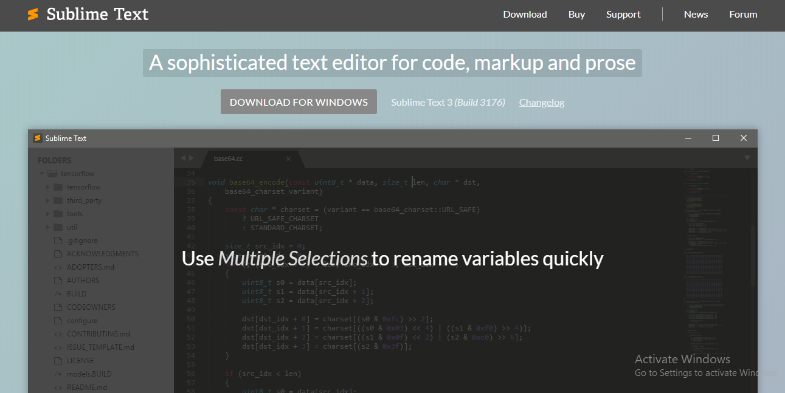

Sublime Text 3 (ST3) is the latest version of the most used text editor by web developers, coders, and programmers. It is available for Mac, Windows, Linux and allows for free download and use.

Link software Sublime Text 3: (<https://www.sublimetext.com/>)

**\*Xampp:**

XAMPP is a well-known and commonly used software application used by developers to build and develop PHP language website projects. XAMPP is installed and run directly in the Windows environment.



Link software Xampp :(<https://www.apachefriends.org/download.html>)

Some pictures about my website:

**\*Bootstrap:** Link software Bootstrap (<http://getbootstrap.com.vn/>)

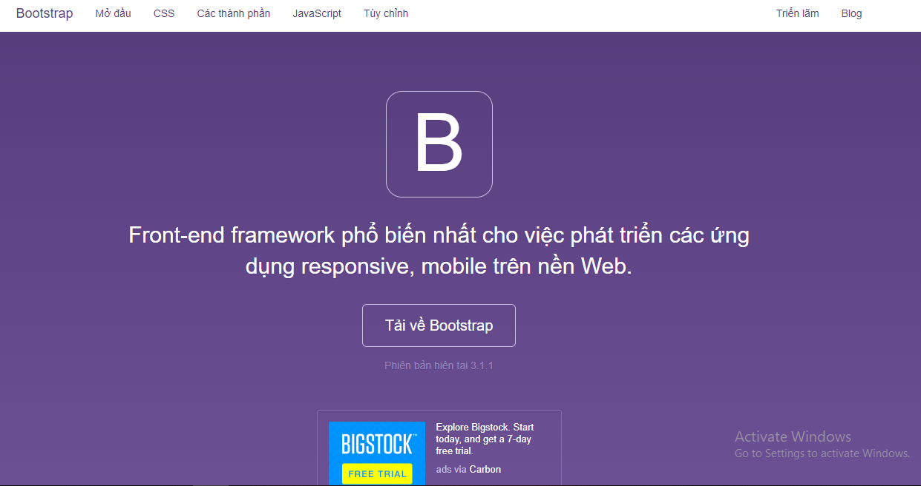

-Bootstrap is the most popular HTML, CSS and JavaScript framework for developing, mobile integration sites.

-Bootstrap includes basic CSS HTML code for typography, forms, buttons, tables, grids, navigation, and many other components in a website. This helps designers avoid having to repeat the process of creating CSS classes and the same HTML code during web design. The style of the HTML elements in Bootstrap is quite simple and elegant. Examples include shadowing in input, highlighting of tables, CSS codes showing warnings, tabs, paging.

Source reference(https://www.webico.vn/bootstrap-la-gi-gioi-thieu-va-huong-dan-cach-su-dung-bootstrap-3/)

-Advantages:

-Ability to create quick interface with components without repeating the process of writing HTML or CSS class code.

- Optimized platform: Bootstrap is built with a storage library that you can easily use and customize according to your purpose.

- Bootstrap is designed with compatibility on many browsers and devices.

- Good interaction with smartphones: If before, websites often have to use 2 versions of programming for PC and phone, now, with the appearance of Bootstrap, your website will be responsive support by default, help the website improve the performance when users access on mobile.

- Full and luxurious interface: The interface is supported almost all the necessary components for website design.

- Easy to customize: To be able to meet many types of websites, Bootstrap is also supported to add customization features, so you can change most of its properties to suit your program.

- Bootstrap is developed friendly to Google so it can also be considered an advantage for you to improve your website ranking on search engines.

Source reference: (https://sites.google.com/site/ithietkewebsite8888/kien-thuc-web/uu-nhuoc-diem-cua-thiet-ke-website-bang-bootstrap)

1)**Home page**: Based on customer design and standards documents, my website is complete with an easy-to-use and customer-friendly interface.

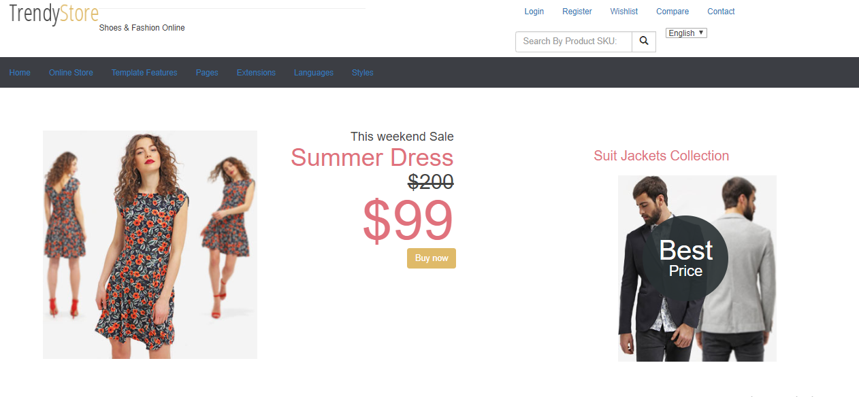

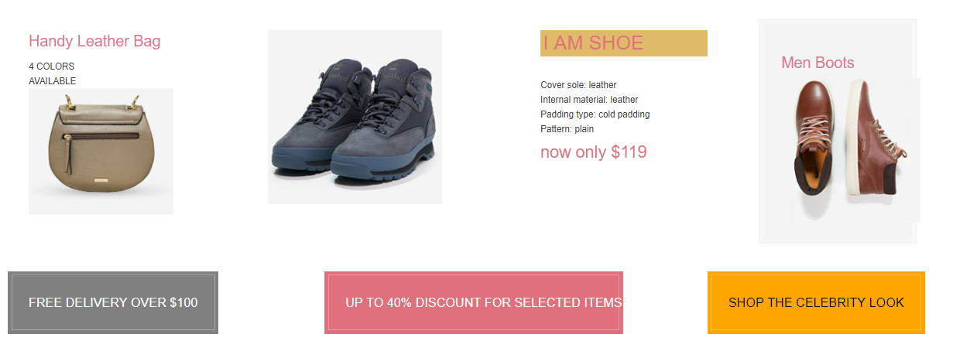

The products are clearly displayed, information and prices.

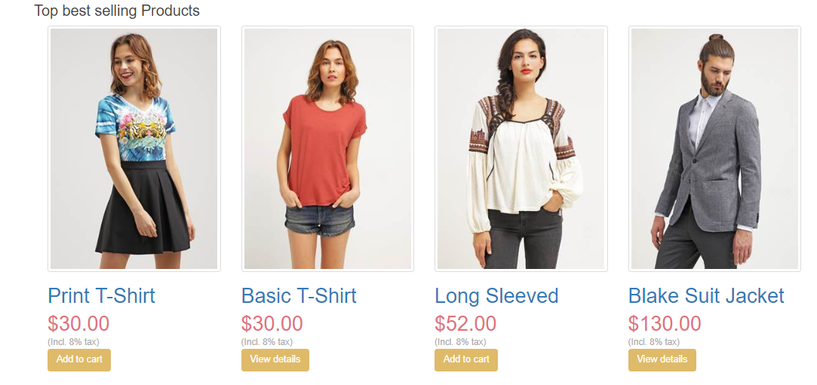

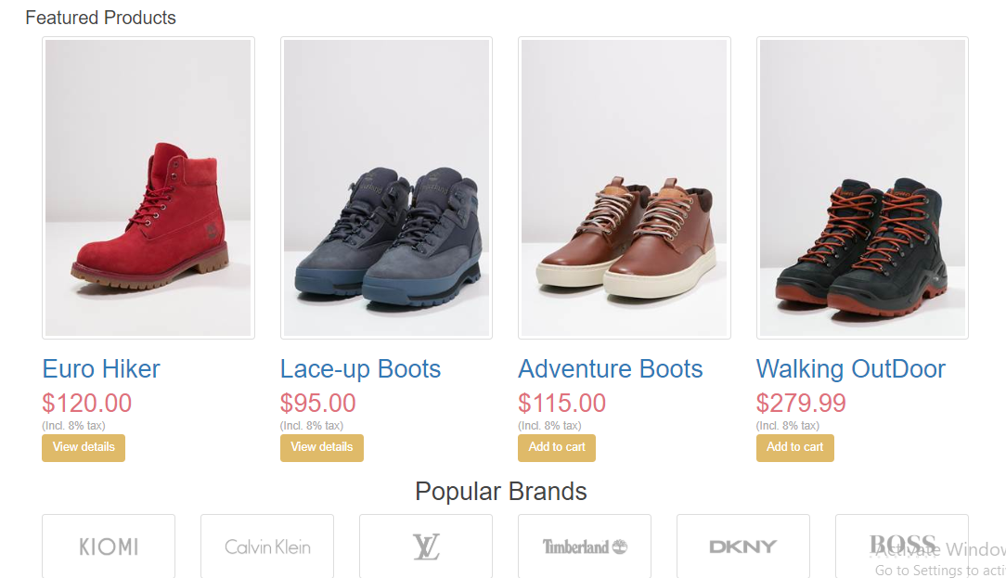

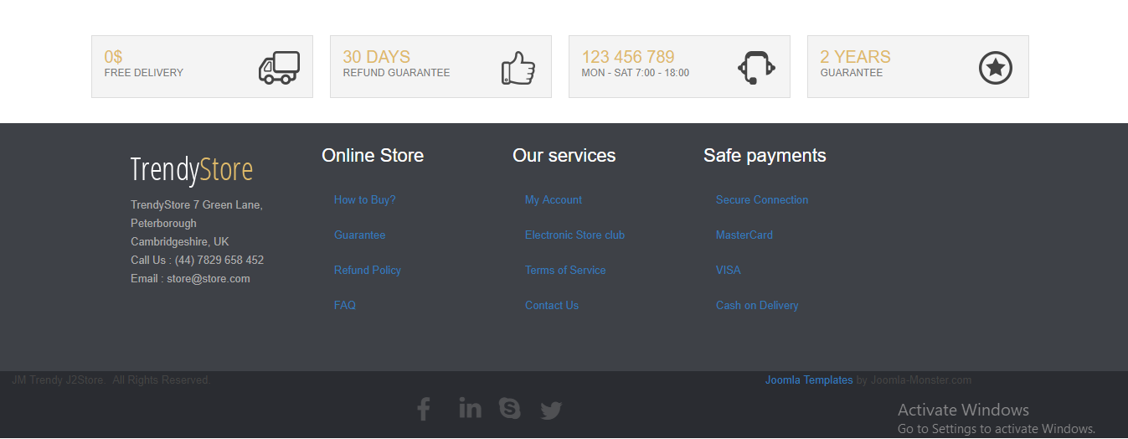

2) **Login Page:** When you press the button login, login interface will appear like this. Complete the information then click on **Login** button, if you forget password can click forget password or username? to move Register page:

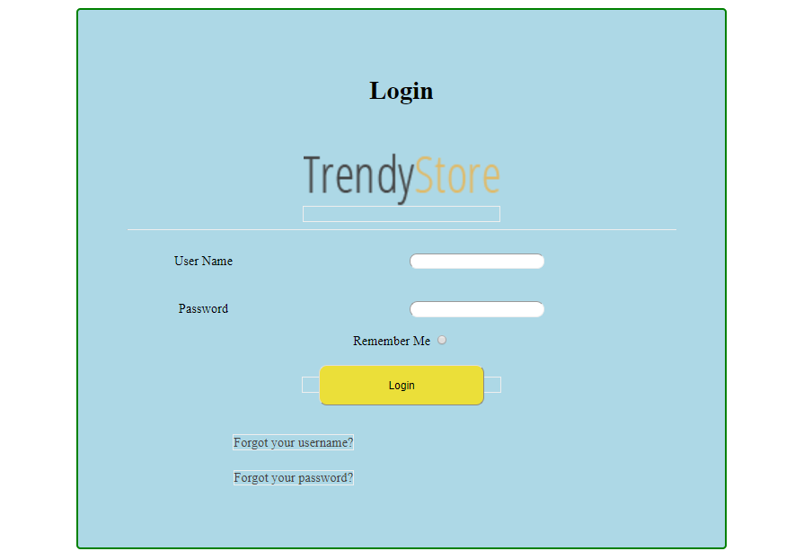

3) **Register page**: Complete the information then click on **Registration** button to create an account to for convenient transactions.

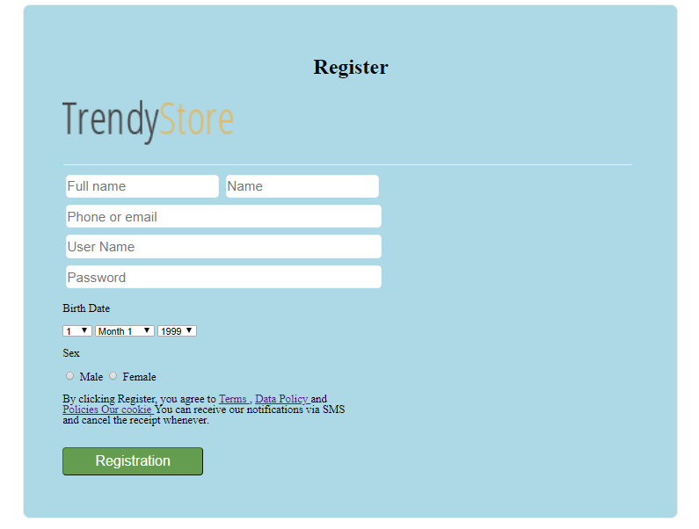

4) **Detail products page**: All items have clear information, if the customer clicks on the product, all information about the item, contact phone number and transaction will be displayed.When you click on the **Order online** ,website will go to Payment page.

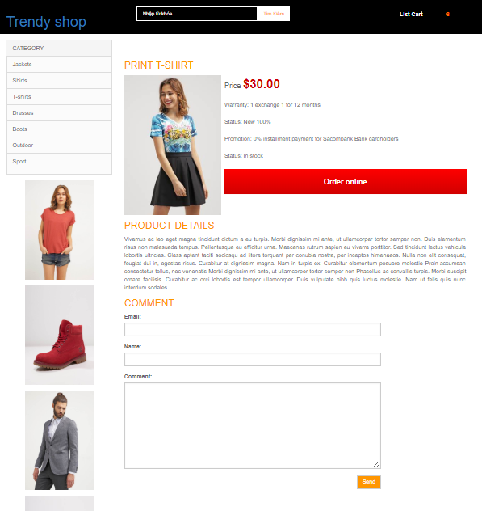

5)**Payment page** : This is the paid interface when buying products in the web.

Complete the information then click on the **Payment** button.

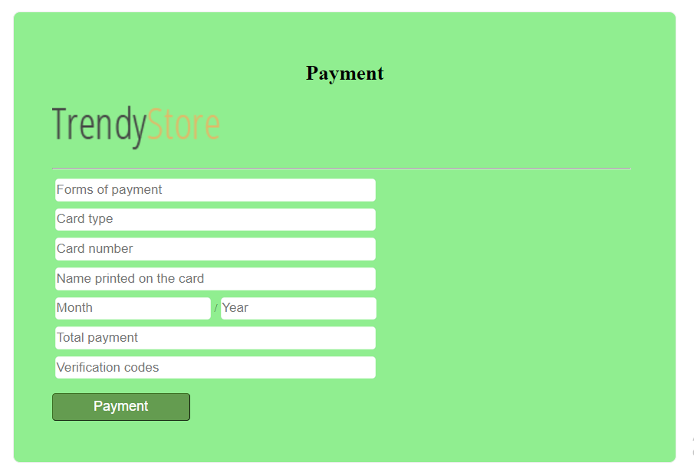

**I use Word to outline the whole site and to make it easier to build and develop**

**Web.**

––

Header

Content

Logo menu navigation

Logo

menu navigation 2

menu navigation 1

Selection

Search

Menu 2

Menu 1

–––

Body

Row

div

div

Image

div

Image

Content

Row

div

div

div

Image

Image

Content

Image

banners

div

div

div

div

Top selling

div

div

div

Featured

div

div

div

div

Brand

icon

Information

div

div

div

div

Footer

div

div

div

Coding

Some evidence of code used for web design: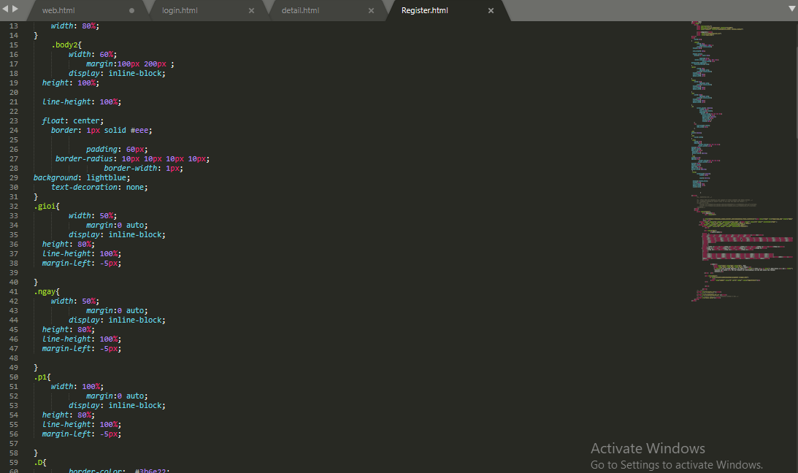

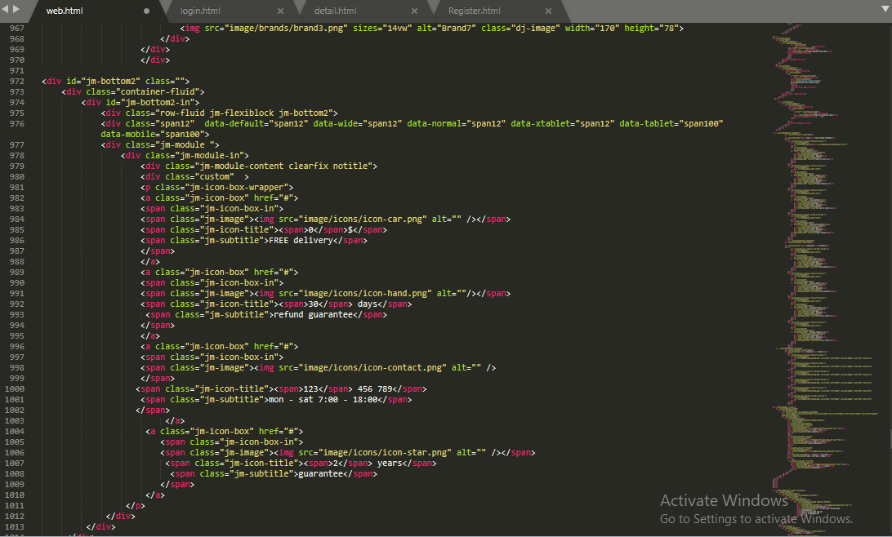

**P6 )Use your design document with appropriate principles, standards and guidelines to produce a branded, multipage website supported with realistic content:**

**1)The Principle:**

Includes 8 basic principles as follows:

1) The website is organized and easy to use.

2) Use words that are easy to understand.

3) Easily explore links.

4) Fast download time.

5) Compatible with most web browsers and devices.

6) Easy to track "sales process".

7) Your website layout should be clear and easy for customers to find information and products

8) Some other important issues when making websites

- Avoid spelling errors.

- Avoid excessive offers.

- Use notification statuses.

Source reference:(<http://www.lamtrangweb.vn/kien-thuc-website/44-nguyen-tac-trong-lam-website-chuyen-nghiep.html>)

**2)The Standards:**

1) Simplicity

+Colors: Don't use too many.

+Typefaces: The typefaces you choose should be legible at the very least. And when it comes to colors, you shouldn't use too many.

+Graphics. Only use them if they'll help a user complete a task or perform a specific function.

2) Visual Hierarchy

When it comes to optimizing for usability and UX, the goal is to lead visitors to complete the desired action, but in a way that feels natural and enjoyable.

3) Navigability

-Keep the structure of your primary navigation simple (and near the top of your page).

-Include a search box near the top of your site so visitors can search by keywords.

-Don't offer too many navigation options on a page.

-Don't dig too deep. In most cases, it’s best to keep your navigation to no more than three levels deep.

-Include links within your page copy, and make it clear where those links lead to.

4) Consistency

In addition to keeping your site's navigation consistent, the overall look and feel of your site should be consistent across all of your site's pages. Backgrounds, color schemes, typefaces, all areas where being consistent can have a positive impact on usability and UX.

5) Accessibility

This means investing in a website structure that is highly flexible -- like responsive design. With a responsive site, content is automatically resized and reshuffled to fit the dimensions of whichever device a visitor happens to be using like the normal size of phone, or laptop, pc, iPad, etc..

6) Conventionality

-Having the main navigation be at the top (or left side) of a page

-Having a logo at the top left (or center) of a page

-Having that logo be clickable so it always brings a visitor back to the homepage

-Having links change color/appearance when you hover over them

7) Credibility

If you're striving to build a site that provides the best user experience possible, using web design conventions that visitors are already familiar with can help give your site more credibility.

8) User-Centricity

-To improve the design of your site is to conduct user testing, gather feedback, and make changes based on what you've learned.

Source refrence:(<https://blog.hubspot.com/blog/tabid/6307/bid/30557/6-guidelines-for-exceptional-website-design-and-usability.aspx>)

**3) Instructions for creating a website:**

Step 1: Get the website design requirements

-Recognize the feature requirements of the website

-Recognize the fine art requirements for the website

-Recognize the requirements for the domain and website hosting (hosting)

-Receive materials, information, and images for website design

Step 2: Select domain name - Web Hosting

-Domain name registration:

It is your website address whenever others access your website, for example:Trendyshop.com. For domain names such as .coc, .net, .org, .vn, .com.vn ... then you must register at domain name agents and pay an activation fee and annual maintenance fee.

In Vietnam, you can register domain names at major domain name providers such as Mat Troi, PA Vietnam ...

Create Hosting

-Hosting is the place to store your website, Hosting, you also have to register at the network providing domain names. It is possible to contact hosting providers such as Mat Troi, PA Vietnam ... Just like domain names, hosting just needs to call the above centers and those centers will advise you.

Step 3: Art design

- Based on the color tone of the Logo

- Based on the requirements of the meaning of the website

- Based on the domain or subject of the website

- Based on the required by customers.

Step 4: Build the main features of the website

- Building the main and basic features of the website as eye-catching, easy to use, friendly,v.v

Step 5: Complete the website:

-General outline of the entire site to give an overall view.

-After coding, check whether the website has met the requirements, or is it consistent, clear.

-Always put test case, plan test to test and test, maintain a website.

-Always update and complete the detailed features, basic content of the site.

**P7) Test Plan and what has not been achieved on this site:**

**1)Test plan :**

|  |  |  |  |  |  |  |  |  |
| --- | --- | --- | --- | --- | --- | --- | --- | --- |
| Test | What is being  tester | How | Test data  use | Expected  Results | | Date | Actual  Result | Action  Taken |
| 1 | Check the effect of the logo in the head of the page. | Click on the Trendy Shop logo | Logo | | Go to the homepage | 27/12/2018 | Success |  |
| 2 | Check the effect of Login button | Click on the  Login button | Login button | | Go to the login page | 27/12/2018 | Success |  |
| 3 | Check the effect of Register button | Click on the  Register button | Register button | | Go to the Register page | 27/12/2018 | Success |  |
| 4 | Check the effect of Search  button | Input information and click  or enter to find product | Search button | | Can find information when click  or enter | 27/12/2018 | Fail |  |
| 5 | Try again.  check the effect of Search  button | Input information like: Shirt  and click  or enter to find product | Search button | | Can find information when click  or enter  If not successful, cancel this function. | 27/12/2018 | Fail |  |
| 6 | Check the effect of Select language  button | Click on the Select language button | Select language button | | Switching between English language and Arabic | 27/12/2018 | Fail |  |
| 7 | Try again.  check the effect of Select language  button | Click on the Select language button | Select language button | | Switching between English language and Arabic  If not successful, cancel this function. | 27/12/2018 | Fail |  |
| 8 | Check the effect of menu bar | Click on the  menu bar | Menu bar | | Can drop down information or other options | 27/12/2018 | Fail |  |
| 9 | Try again  Check the effect of menu bar. | Click on the  menu bar | Menu bar | | Can drop down information or other options  If not successful, cancel this function | 27/12/2018 | Fail | Canceled |
| 10 | Check the effect of Buy now button | Click on the Buy now button | Buy now button | | Go to the payment page | 27/12/2018 | Success |  |
| 11 | Check the effect of how to see detail of product | Click on the name of product | Name of product | | Go to the detail page | 27/12/2018 | Success |  |
| 12 | Check the effect of how to see detail of product | Click on the Add to cart button | Add to cart button | | Go to the detail page | 27/12/2018 | Success |  |
| 13 | Check the effect of how to see detail of product | Click on the View details button | View details button | | Go to the detail page | 27/12/2018 | Success |  |
| 14 | Check the effect of Order online  button | Click on the Order online  button | Order online  button | | Go to the payment page | 27/12/2018 | Success |  |
| 15 | Check the effect of Forgot your user name?  button | Click on the Forgot your user name?  button | Forgot your user name?  button | | Go to the register page | 27/12/2018 | Success |  |
| 16 | Check the effect of Forgot your password?  button | Click on the Forgot your password?  button | Forgot your password?  button | | Go to the register page | 27/12/2018 | Success |  |

**2) What has not been achieved on this site:**

-Overall, the website is still not flexible but still easy to use and eye-catching, there are many points that are not as vivid as the original website.Carousel image cannot yet be made:





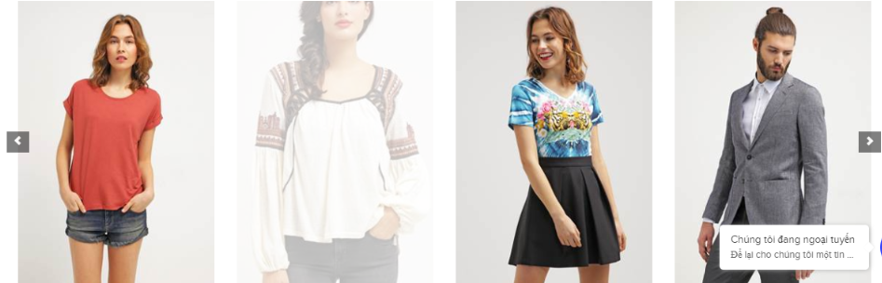



- Some shortcomings of the site:

+ Search button: Cannot search for information

+ Language selection button: Cannot switch to Arabic language.

+ Drop button: Cannot display content, or other options.



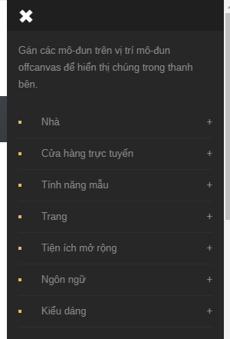

+ Menu bar can't drop down information or other options



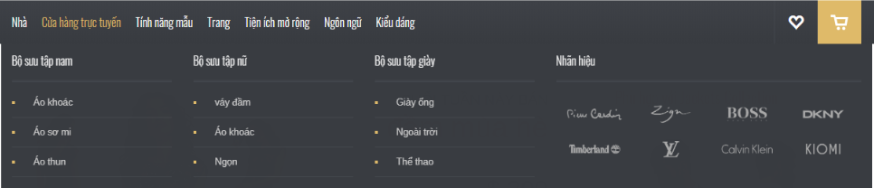

+ Not able to connect to the backend even though there have been many attempts.